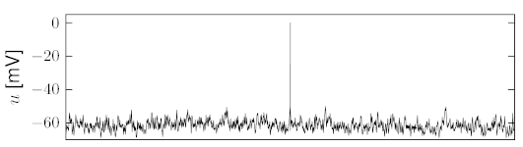

1  
  
0

Start of Delayed Signal

Recording frame

Spike Detected

Record Trigger